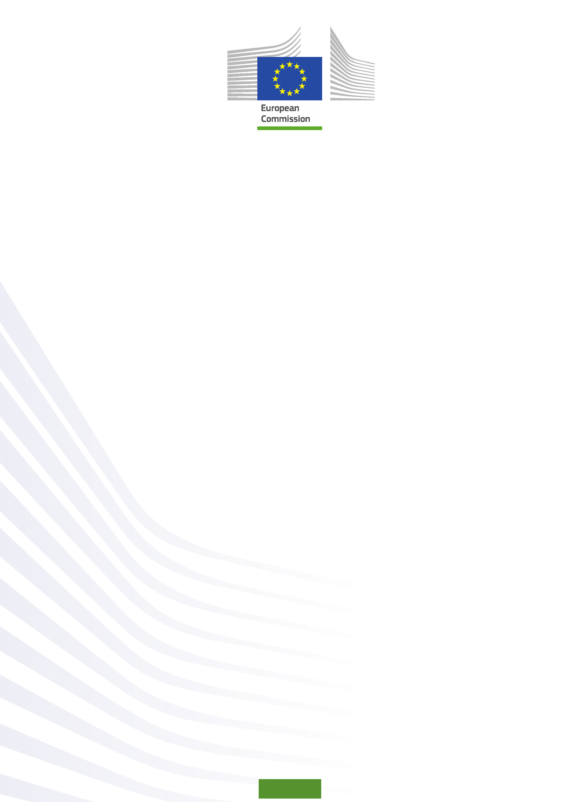
Training packages for health professionals to improve access and quality of health services for migrants and ethnic minorities, including the Roma
MEM-TP

ADDITIONAL MODULE 1: TARGET GROUPS
Unit 3: REFUGEE AND ASYLUM SEEKERS

Guidelines

Prepared by:
Olga Leralta
Andalusian School of Public Health, 2015

© European Union, 2015
For any reproduction of textual and multimedia information which are not under the © of the European Union, permission must be sought directly from the copyright holders.

© Cover Illustrations: Observatorio de la Infancia de Andalucía, Escuela Andaluza de Salud Pública. Junta de Andalucía.


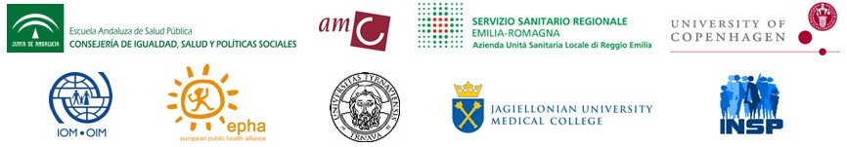
Migrants & Ethnic Minorities Training Packages

Funded by the European Union in the framework of the EU Health Programme (2008-2013) in the frame of a service contract with the Consumer, Health, Agriculture and Food Executive Agency (Chafea) acting under the mandate from the European Commission. The content of this report represents the views of the Andalusian School of Public Health (EASP) and is its sole responsibility; it can in no way be taken to reflect the views of the European Commission and/or Chafea or any other body in the European Union. The European Commission and/or Chafea do not guarantee the accuracy of the data included in this report, nor do they accept responsibility for any use made by third parties thereof.

Unit 3: REFUGEE AND ASYLUM SEEKERS

1. Objectives and Methods

Time | Objectives | Activities | Sources
20 minutes | - To provide an evidence-based update on Refugee and Asylum seekers’ health.  - To identify major trends in the health status of Refugee and Asylum seekers. | Presentation “Migrants in an irregularized situation” and questions | Projector, laptop, screen.
40 minutes | - To identify strategies for improving access to health care for Refugee and Asylum seekers in your region / country, and prioritize these strategies according to their perceived relevance. | Activity in three parts:  - Presentation of the methodology  - Small Groups: Nominal group technique  - Plenary: Wrap up and discussion | Projector, laptop, screen.  Cards, markers, flip chart, adhesive (spray), self-adhesive dots.

2. Presentation

Slide 1
Information for this document was obtained from:
- Mock-Muñoz de Luna C, Ingleby D, Graval E, Krasnik A. Training packages for health professionals to improve access and quality of health services for migrants and ethnic minorities, including the Roma: Synthesis Report: Work package 1 MEM-TP project. [Copenhagen]: University of Copenhagen; 2014.
- European Council for Refugees and Exiles. Good practice guide on the integration of refugees in the European Union: Health
http://www.ecre.org/component/downloads/downloads/187.html (retrieved: November 25, 2014)

Slide 2
Asylum seekers flee their country because they have a “well-founded fear of being persecuted” due to their race, religion, nationality, membership of a particular social group or political opinion. They apply for refugee status under the 1951 Geneva Refugee Convention. Those granted this status become refugees while those not granted may be awarded another (generally weaker) form of ‘subsidiary’ or ‘humanitarian’ protection; otherwise they will be required to leave the country. An unknown number, however, do not do so and continue to live in the country as “irregular” migrants. Often, they have faced major difficulties on their way to Europe, and in Europe they are likely to be further excluded from society.

European legislation relevant to the protection of Asylum seekers and refugees health:
- Council of Europe (2001). Recommendation 1503 of the Parliamentary Assembly regarding Health conditions of migrants and refugees in Europe.
- Council of Europe (2003). Council Directive 2003/9/EC of 27 January 2003 laying down minimum standards for the reception of asylum seekers.
- Council of Europe (2007). Bratislava Declaration on Health, Human Rights and Migration.
- Council of Europe (2008). Resolution 1637 (2008). Europe’s boat people: mixed migration flows by sea into southern Europe.

Regarding access to health services, the 1951 Refugee Convention states that refugees should enjoy access equivalent to that of the host population (Article 23, Refugee Convention of 1951). UMHCR Strategy 2014-2018 mentions the need for special measures to ensure inclusiveness and accessibility for specific groups of concern, including women, adolescent girls and boys, the elderly, the young, people with disabilities, people who are lesbian, gay, bisexual, transsexual or intersex, and women and men belonging to national or ethnic, religious and linguistic minorities or indigenous groups.

Slide 3
Asylum claims
There are approximately 1.5 million recognised refugees living in the twenty seven Member States of the European Union plus Norway and Switzerland. This compares to a global figure of approximately 16 million. There are wide variations in the number of asylum seekers coming to any given country, reflecting changing patterns of international humanitarian crises, the country’s readiness to grant asylum or subsidiary/ humanitarian protection, and the country of origin of arriving asylum seekers. In 2013, Germany, France, Sweden, the United Kingdom and Italy registered 70% of all applicants .
Regarding asylum claims, figures from 2013 continued the increase that started in 2010 and reached the highest level in Europe for a decade. The main countries of origin of asylum seekers were Syria, Russian Federation, Afghanistan, Iraq and Serbia/Kosovo. According to UNHCR, six nations on southern Europe (Cyprus, Greece, Italy, Malta, Portugal and Spain) have a sustained increase in the number of asylum claims.

Figure 1 Variation in asylum claims lodged in 44 industrialized countries 1990-2012

Slide 4

Health concerns
The basic health needs of refugees and asylum seekers are broadly similar to those of the host population, although previous poor access to health care may mean that many conditions have been untreated. Many refugees, in particular those moving from a poor socioeconomic environment to Europe, suffer from communicable diseases, such as tuberculosis or hepatitis, as well as respiratory diseases associated with poor nutrition, the cold, overcrowding, and inadequate sanitation, water supply and housing, compounded by limited access to health care. Symptoms of psychological distress are common but do not necessarily signify mental illness. Many refugees experience difficulties in expressing health needs and in accessing health care. Poverty and social exclusion also have a negative impact on their health.
People who are seeking asylum are not a homogeneous population. Coming from different countries and cultures, they have had, in their own and other countries, a wide range of experiences that may affect their health and nutritional state. Refugees can suffer from a range of health problems relating to their experience of political persecution, imprisonment, torture and the conditions of flight from their country of origin.

Once in the country of asylum, refugees’ health can also be affected by a serious decline in their standards of living (housing conditions, unemployment or underemployment, social isolation and low income). Other external factors in the settlement phase such as insecurity of the asylum application, fear for the safety of family members, legal and bureaucratic difficulties in family reunification, adaptation to the new environment (e.g. new language, habits and culture) and hostile attitudes within the country of asylum might have an impact on refugee health, especially mental health. ECCRE has reported the negative impact on health of the long waiting period for the processing of an asylum application (smoking, drinking, drug abuse and suicide attempts are also known to increase during such a period); a long stay in a reception centre and / or in bad housing conditions; prolonged inactivity.

Slide 5
Health risks on the journey
As reported by MSF undocumented migrants and asylum seekers set off to South Europe on boats leaving the coast of Libya, Algeria and Morocco on journeys that can take up to seven days. Nearly 60% of those arriving to Malta originate from countries affected by conflict or widespread violations of human rights as Somalia. Although most of them will eventually be granted refugee status or humanitarian protection by Maltese authorities, they are sent to detention centers where they face overcrowding, inadequate sanitation, and poor general living conditions, an environment that has damaging effects on their physical and mental health. About 17% of the health conditions diagnosed by MSF medical staff were respiratory problems linked to exposure to cold and lack of treatment for infections. Skin infections reflected overcrowding and poor hygiene in the centers.

Each year, thousands of migrants arrive in Lampedusa and Andalusia after harsh boat journeys across the Mediterranean Sea to Europe. Those who survive the journey arrive exhausted and dehydrated, suffering from respiratory infections and skin complaints caused by overexposure to salt and water, as well as burns from fuel accidents.

The majority of people arriving without legal documents to Greece originate from Afghanistan, Iraq, Palestinian Territories, and Somalia. For these arrivals, Southern European countries are usually a transit location on the way to Northern Europe.

Morocco is a place of transit and enforced stay for migrants from sub-Saharan Africa. The presence of migrants in some rural areas of the border with Algeria and Spanish cities of Ceuta and Melilla has led to regular raids by Moroccan security forces. MSF has reported violence suffered by migrants and asylum seekers from both the security forces and other actors e.g. human-trafficking networks. Because migrants are forcibly detained in Morocco, risky behaviours have started to appear, linked to activities that generate economic income. These activities include sexual exploitation, prostitution, and forced labour linked to human-trafficking networks. As a consequence, migrants face new health problems linked to sexual and reproductive health.

Post-traumatic stress disorder (PTSD) and refugee mental health problems
Refugees often suffer from various mental health problems due to atrocities faced before or during displacement, including violence, separation, torture, killing, massive destruction, sexual and gender based violence and child soldiering. This trauma is often compounded by a generalized sense of hopelessness among refugees, absence of employment opportunities, and social dysfunction.

Refugees are also frequently diagnosed with symptoms of post-traumatic stress disorder, depression, psychosomatic complaints and anxiety. Addressing these mental health concerns and ensuring an adequate response is often problematic due to the very difficult geographical and political situations in which refugees find themselves, as well as lack of resources to mount an adequate response.

Although a meta-analysis showed a prevalence of 9% among refugees, which is around ten times higher than in the general population, another meta-analysis concluded that rates of depression were twice as high among refugees as among labour migrants (44% versus 20%). The same was true for anxiety disorders (40% versus 21%). Mental health problems among refugees are thus not simply a matter of post-traumatic stress reactions. Moreover, the origin of these problems may lie not in the country of origin, but in experiences endured during the flight and the asylum application procedure.

Slide 6

Women Refugee
They are vulnerable to physical assault, sexual harassment, and rape. As refugees, they may have to take on new roles and responsibilities, including being heads of disrupted households; they may also have to assume responsibility within the community for education and cultural cohesion. According to data they are more likely than men to report poor health and depression; screening and health promotion programmes tend to have a low uptake among refugee women. Some women will have undergone genital mutilation and that this can affect sexual health and childbirth.

Children Refugee
Children may be living in a fragmented family, be with unfamiliar carers, or have arrived alone. They may have experienced violence or torture themselves or have witnessed atrocities; some may have been abducted to become child soldiers and forced to commit violent acts themselves. They may have developmental difficulties, seeming to be mature beyond their years and in a caring role with their parents yet be immature in other situations such as school. They may show anxiety, nightmares, withdrawal, or hyperactivity but few need psychiatric treatment. Support for children needs to be multifaceted, aiming to provide as normal a life as possible, imparting a sense of security, promoting education and selfesteem. It is also important to support parents, as they may be facing difficulties themselves.

Slide 7

Provision of health services in EU

Up to a point, free health care is provided to asylum seekers (who, as long as their application is being processed, are in care of the State). The 2003 EC Minimum Standards Directive requires member states to provide at least free emergency care to this group, and to pay special attention to the needs of ‘vulnerable’ asylum seekers. However, there are considerable variations in the extent of the care provided and the conditions attached to it e.g. whether it is available outside asylum-seeker centres. An earlier overview of coverage for asylum seekers was published in 2006.

Some European countries, because of financial constraints, limit the access and treatment of asylum seekers and humanitarian refugees to necessary care only. Some of them provide asylum seekers with a health check-up on their arrival; some others neither entitle asylum seekers to access to the health system nor provide them with any medical reception.

2. Activity

Slide 8: Activity: Strategies for Improving Access to Health Care for Refugees and Asylum Seekers

The activity consists of three parts:

1. Presentation of the methodology

2. Identification and prioritization of strategies for improving access to health care for migrant and ethnic minority population groups in situation of social vulnerability, in small groups (8-10 people)

Method: Nominal group technique.
Moderation: 1-2 facilitators / group.
Materials: Cards, markers, flip chart, adhesive (spray), self-adhesive dots.

Technique:
- The participants are invited to write down the 3 most relevant strategies they identify for improving access to health care for migrant and ethnic minority population groups in situation of social vulnerability in their region / country (one idea / card).
- The facilitators collect the cards, reading and arranging the named aspects by topics on a flip chart.
- The participants are asked to prioritize the most important strategies (3 dots / person).
- The participants choose a rapporteur, in charge of summarizing the most relevant aspects in the plenary.

3. Wrap up and discussion in plenary
- Wrap up: The rapporteur of each small group provides a summary of the results, in three sentences.
- Group discussion.

http://www.ecre.org/refugees/refugees/who-are-refugees.html
http://assembly.coe.int/Main.asp?link=/Documents/AdoptedText/ta01/EREC1503.htm
http://europa.eu/legislation_summaries/justice_freedom_security/free_movement_of_persons_asylum_immigration/l33150_en.htm (retrieved: July 25, 2014)
http://www.coe.int/T/DG3/Health%5CSource%5Cdeclaration_en.pdf (retrieved: July 25, 2014)
http://assembly.coe.int/Main.asp?link=/Documents/AdoptedText/ta08/ERES1637.htm (retrieved: July 25, 2014)
Global strategy for public health. A UNHCR strategy 2014-2018
2009 Global Trends, United Nations High Commissioner for Refugees. http://www.unhcr.org/4c11f0be9.html (retrieved: November 25, 2014)
Eurostat (2014) Eurostat Newsrelease 46/2014 – 24 March 2014. Luxembourg: Eurostat.
UNHCR (2014), Asylum Trends 2013. Levels and Trends in Industrialized Countries. New York: United Nations High Commissioner for Refugees.
Poverty and social exclusion in the WHO European Region: health systems respond. Copenhagen, WHO Regional Office for Europe, 2010.
UNHCR (2013), Asylum Trends 2012. Levels and Trends in Industrialized Countries. New York: United Nations High Commissioner for Refugees. (Note that the definition of ‘Europe’ in this graph includes 38 countries)
ECCRE Good practice guide on the integration of refugees in the European Union: Health http://www.ecre.org/component/downloads/downloads/187.html
Medecins sans Frontières, Migrants, refugees and asylum seekers: Vulnerable people at Europe’s doorstep http://www.doctorswithoutborders.org/sites/usa/files/MSF-Migrants-Refugees-AsslymSeekers.pdf (retrieved: November 25, 2014)
Medecins sans Frontières, Migrants, refugees and asylum seekers: Vulnerable people at Europe’s doorstep http://www.doctorswithoutborders.org/sites/usa/files/MSF-Migrants-Refugees-AsslymSeekers.pdf (retrieved: November 25, 2014)
UNHCR Strategy 2014-18
Fazel, M., Wheeler, J., Danesh, J. (2005). Prevalence of serious mental disorder in 7000 refugees resettled in western countries: a systematic review. The Lancet, 365:9467:1309–1314.
Lindert, J. et al. (2009). Depression and anxiety in labor migrants and refugees – a systematic review and meta-analysis. Social Science & Medicine, 69:2:246–257.
Ingleby, D. (ed.) (2005) Forced migration and mental health: rethinking the care of refugees and displaced persons. New York: Springer.
Burnett A, Peel M. (2001) Health needs of asylum seekers and refugees. BMJ: British Medical Journal 322(7285):544-547.
Norredam, M., Mygind, A & Krasnik, A. (2006) Access to health care for asylum seekers in the European Union — a comparative study of country policies. Eur J Public Health 16(3): 285-289.
ECCRE Good practice guide on the integration of refugees in the European Union: Health http://www.ecre.org/component/downloads/downloads/187.html

