
Training packages for health professionals to improve access and quality of health services for migrants and ethnic minorities, including the Roma
MEM-TP
Module 3: PROFESSIONAL SKILLS
Training Unit: Interpersonal skill development

Activity 5. Negotiation process

Prepared by:
Andalusian School of Public Health

© European Union, 2015
For any reproduction of textual and multimedia information which are not under the © of the European Union, permission must be sought directly from the copyright holders.

© Cover Illustrations: Observatorio de la Infancia de Andalucía, Escuela Andaluza de Salud Pública. Junta de Andalucía.

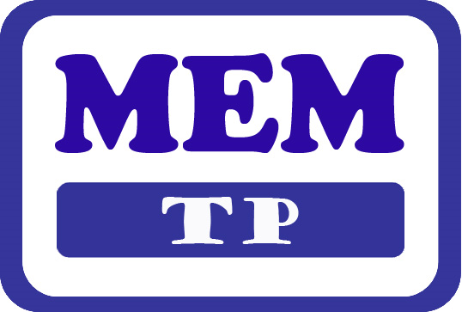

Migrants & Ethnic Minorities Training Packages

Funded by the European Union in the framework of the EU Health Programme (2008-2013) in the frame of a service contract with the Consumer, Health, Agriculture and Food Executive Agency (Chafea) acting under the mandate from the European Commission. The content of this report represents the views of the Andalusian School of Public Health (EASP) and is its sole responsibility; it can in no way be taken to reflect the views of the European Commission and/or Chafea or any other body in the European Union. The European Commission and/or Chafea do not guarantee the accuracy of the data included in this report, nor do they accept responsibility for any use made by third parties thereof.
Module 3: PROFESSIONAL SKILLS

Training Unit: Interpersonal skill development

Activity 5. Negotiation process

Description: Guided discussion about the experience of participants in negotiation and collaboration processes to solve conflicts in their daily practise.
Time: 15 minutes
The activity consists of three parts:
1. Ask the participants to individually think of a situation they have experienced. They can fill-in the template (check-list of the steps to negotiate).
2. List on the board participants’ contributions regarding their experience in negotiation and collaboration to solve problems in the interaction between health services and migrants and ethnic minorities.
3. Discussion in group supported by the presentation contents.

Negotiation process check-list:

Did you listen to the patient’s demand or ask them to formulate it explicitly?
Did you assume that everything was understood?
Did you contribute with possible solutions to the problem and / or demand?
Did you ask the patient about their purposes?
Did you ask them why it was important for them?
Did you respond to the patient’s demand (totally or partially)
Did you reject part of the demand? If so why?
Was the patient committed to doing something in exchange?
Did you close an agreement?
Did you compliment the patient's attitude to create a positive reinforcement?

