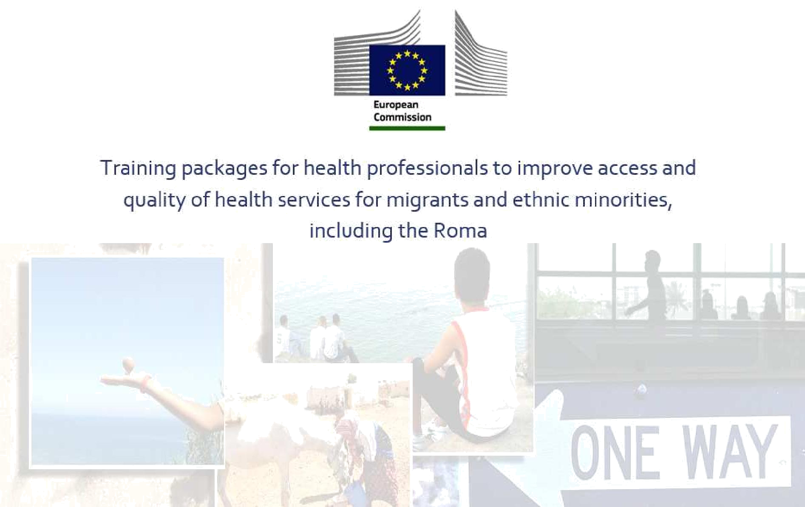

MODULO AGGIUNTIVO 1: DESTINATARI

Unità 2: Migranti in una condizione “irregolare”

Amets Suess, Scuola Andalusa di Salute Pubblica, 2015

Schema della sessione

- Presentazione:

Concetti

Studi comparativi nel contesto europeo Impatto dell’attuale crisi economica

Barriere all’accesso reale all’assistenza sanitaria Raccomandazioni da rapporti comparativi
- Attività: Strategie per migliorare l’accesso all’assistenza sanitaria per i migranti in una condizione “irregolare”

Migranti in una condizione “irregolare”: Concetti

- Terminologie e concettualizzazioni

“Immigrati illegali” “Immigrati irregolari” “Clandestini”

“Migranti in una condizione “irregolare”

“Migranti in una condizione “non regolarizzata”

- Discussione teorica e politica correlata all’uso della terminologia.

- Carattere complesso dello status di migrante.

- Uso della terminologia nell’ambito del progetto MEM-TP:

“Migranti in una condizione “irregolare”

Partendo dall’idea che la persona non è “irregolare”/“illegale”, il quadro legale “irregolarizza” lo status amministrativo del migrante.

Duvell, et al. 2008; Global Commission on International Migration 2005;Mock-Muñoz de Luna, et al. 2015; Morehouse, et al. 2001; PICUM 2014; Vollmer 2011.

Migranti in una condizione “irregolare”:

Studi comparativi nel contesto europeo

- Studi comparativi

Singoli autori

Agenzie europee

Associazioni professionali

Organizzazioni della società civile

- Aspetti pertinenti

Quadro europeo e internazionale dei diritti umani

Analisi dei diritti all’assistenza sanitaria dei migranti in una condizione “irregolare”. Barriere nell’accesso reale all’assistenza sanitaria.

Rischi per la salute correlati alla limitazione/all’assenza di accesso all’assistenza sanitaria. Ruolo delle politiche sanitarie locali e regionali.

Impatto dell’attuale crisi economica e sistemica. Raccomandazioni.

Biswas, et al. 2011; Cuadra 2011; Dauvrin, et al. 2012; Duvell, et al. 2009; FRA, European Union Agency for Fundamental Rights 2011a, 2011b; HUMA Network, et al. 2009; 2010; Karl-Trummer et al. 2010; Médicins du Monde, et al. 2009, 2012, 2013; PICUM, et al. 2009a, 2009b, 2009c, 2010, 2012, 2013a, 2013b, 2014a, 2014b; Ruiz-Casares, et al. 2010; Suess, et al. 2014a; Woodward, et al. 2014.

Migranti in una condizione “irregolare”:

Impatto dell’attuale crisi economica
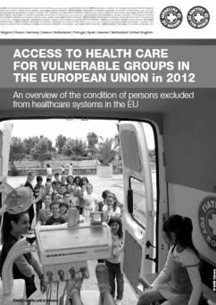

- Situazione attuale dei gruppi di popolazione in situazioni di vulnerabilità sociale, inclusi i migranti in una condizione “irregolare”, in 5 città europee (2012) e in 14 città di 7 paesi europei (2013).

- Aumento della disoccupazione e della xenofobia.

- Limitazione dei diritti all’assistenza sanitaria.

- Introduzione di ticket per l’accesso ai servizi sanitari.

- Aumento delle barriere nell’accesso reale all’assistenza sanitaria.

- Deterioramento della salute auto-percepita.
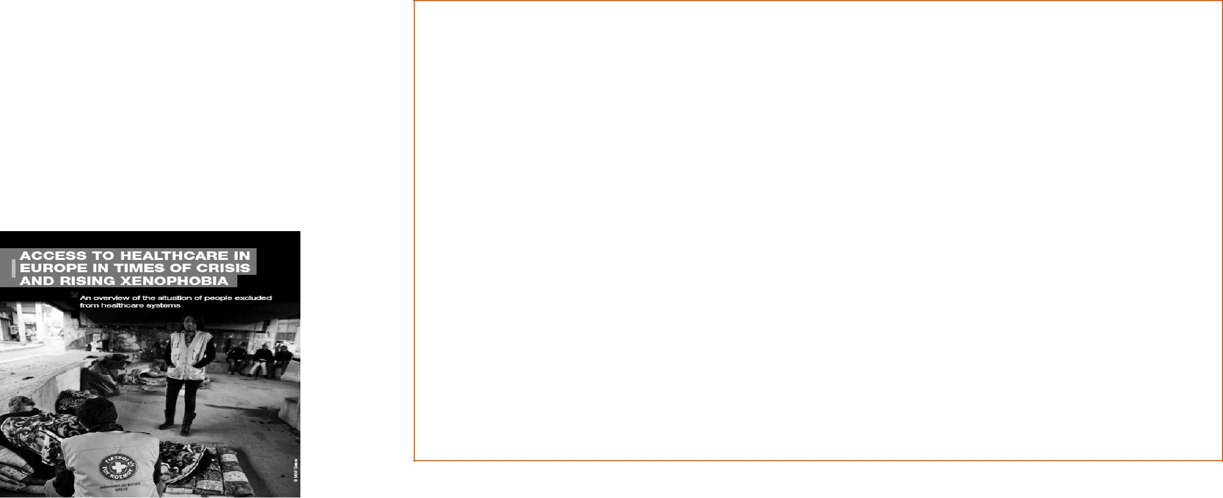

Médicins du Monde 2012, 2013.

2013:

Svezia:

Legge sull’assistenza medico-sanitaria per gli stranieri che vivono in Svezia senza i necessari permessi

2012:

Spagna:

Decreto legge reale 16/2012

2011
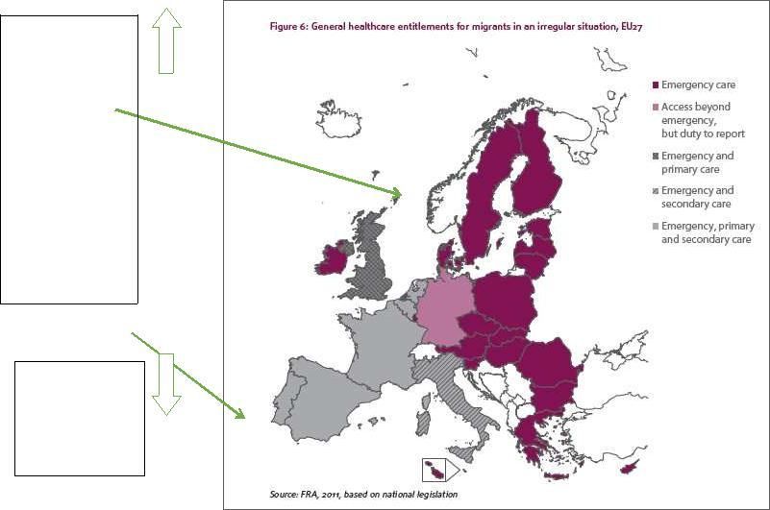

FRA, European Union Agency for Fundamental Rights 2011a; PICUM 2014b.

Migranti in una condizione “irregolare”:

Barriere all’accesso reale all’assistenza sanitaria

- Limitazione o assenza dei diritti all’assistenza sanitaria.

- Mancanza di conoscenza dei diritti esistenti da parte dei professionisti, del personale amministrativo e dei migranti.

- Complessità delle procedure amministrative.

- Obbligo di rimborso nei sistemi di partecipazione finanziaria al costo.

- Timore di denuncia.


Biswas, et al. 2011; Cuadra 2011; Dauvrin, et al. 2012; Duvell, et al. 2009; FRA, European Union Agency for Fundamental Rights 2011a, 2011b; HUMA Network, et al. 2009; 2010; Karl-Trummer et al. 2010; Médicins du Monde, et al. 2009, 2012, 2013; PICUM, et al. 2009a, 2009b, 2009c, 2010, 2012, 2013a, 2013b, 2014a, 2014b; Ruiz-Casares, et al. 2010; Suess et al. 2014a; Woodward, et al. 2014.

Migranti in una condizione “irregolare”:

Barriere all’accesso reale all’assistenza sanitaria
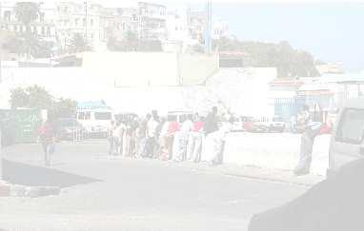

- Aspetti culturali e idiomatici.

- Precedenti esperienze di discriminazione.

- Precarietà della situazione socio-economica, con frequenti cambi o assenza di una residenza permanente.

- Casi di accesso negato nonostante il possesso di diritti.

- Paura dell’impatto negativo di una diagnosi positiva all’HIV sul processo di autorizzazione al soggiorno.

- Difficoltà nell’accedere a un’assistenza sanitaria adeguata nei centri di detenzione.

Amnesty International 2007; Biswas, et al. 2011; Committee on Civil Literties, Justice and Home Affairs, 2007; Cuadra 2011; Dauvrin, et al. 2012; Duvell, et al. 2009; FRA, European Union Agency for Fundamental Rights 2011a, 2011b; HUMA Network, et al. 2009; 2010; Karl-Trummer et al. 2010; JRS-Europe, 2010; Médicins du Monde, et al. 2009, 2012, 2013; Médicins Sans Frontières s.a.; PICUM, et al. 2009a, 2009b, 2009c, 2010, 2012, 2013a, 2013b, 2014a, 2014b; Ruiz-Casares, et al. 2010; Suess et al. 2014a; UN 2012, 2013; Woodward, et al. 2014.

Migranti in una condizione “irregolare”:

Raccomandazioni da rapporti comparativi

- Diritti all’assistenza sanitaria

Parità delle condizioni in relazione alla copertura pubblica, al rimborso o alla partecipazione finanziaria al costo per tutte le persone residenti in un paese, indipendentemente dalla nazionalità, dallo status amministrativo o dalla situazione lavorativa.

Accesso a tutti i livelli di assistenza sanitaria, non solo alle cure di emergenza.

Interruzione del controllo sull’immigrazione durante la fornitura di assistenza sanitaria. Mantenimento dei diritti all’assistenza sanitaria in situazioni di crisi economica.

- Miglioramento dell’accesso reale all’assistenza sanitaria

Rimozione delle barriere culturali, idiomatiche, sociali e strutturali. Fornitura di assistenza sanitaria senza discriminazioni.

Miglioramento dell’assistenza sanitaria nei centri di detenzione. Ruolo delle politiche e degli interventi locali e regionali.

Amnesty International 2007; Biswas, et al. 2011; Committee on Civil Literties, Justice and Home Affairs, 2007; Cuadra 2011; Dauvrin, et al. 2012; Duvell, et al. 2009; FRA, European Union Agency for Fundamental Rights 2011a, 2011b; HUMA Network, et al. 2009; 2010; Karl-Trummer et al. 2010; JRS-Europe, 2010; Médicins du Monde, et al. 2009, 2012, 2013; Médicins Sans Frontières s.a.; PICUM, et al. 2009a, 2009b, 2009c, 2010, 2012, 2013a, 2013b, 2014a, 2014b; Ruiz-Casares, et al. 2010; Suess et al. 2014a; UN 2012, 2013; Woodward, et al. 2014.

Attività:

Strategie per migliorare l’accesso all’assistenza sanitaria per i migranti in una condizione “irregolare”

- Presentazione della metodologia

- In piccoli gruppi

Strategie per migliorare l’accesso all’assistenza sanitaria per i migranti in una condizione “irregolare” nella regione/nel paese.

Prioritizzazione delle strategie.

- In plenaria

Riassunto dei risultati del lavoro dei piccoli gruppi. Discussione di gruppo.



Grazie per l’attenzione. Domande?

Immagini: Andalusian Childhood Observatory (OIA, Observatorio de la Infancia de Andalucía) 2014; Josefa Marín Vega 2014; RedIsir 2014; Morguefile 2014.

Riferimenti bibliografici

Amnesty International. Migration-Related Detention: A research guide on human rights standards relevant to the detention of migrants, asylum-seekers and refugees. London: AI, 2007. http://www.refworld.org/pdfid/476b7d322.pdf (retrieved: March 5, 2015).

Biswas D, Toebes B, Hjern A, Ascher H, Norredam M. Access to health care for undocumented migrants from a human rights perspective: a comparative study of Denmark, Sweden, and the Netherlands. Health and Human Rights 2012;14:2:49-60.

Cuadra BC. Right of access to health care for undocumented migrants in EU: a comparative study of national policies. Eur J Public Health 2011;22:267–271.

Chiarenza A, Horvat L, Ciannameo A, Vaccaro G, Lanting K, Bodewes A, Suurmond J. Final Report Review of existing training materials. MEM-TP, Training packages for health professionals to improve access and quality of health services for migrants and ethnic minorities, including the Roma. Granada, Reggio Emilia, Amsterdam: Andalusian School of Public Health, AYSL of Reggio Emilia, University of Amsterdam, 2015.

Dauvrin M, Lorant V, Sandhu S, et al. Health care for irregular migrants: pragmatism across Europe. A qualitative study. BMC Res Notes 2012;5:99.

Duvell F, Triandafyllidou A, Vollmer B. Ethical issues in irregular migration research. Report on Ethical Issues, Deliverable D2 prepared for Work Package 2 of the research project CLANDESTINO Undocumented Migration: Counting the Uncountable. Data and Trends Across Europe, funded by the 6th Framework Programme for Research and Technological Development Research DG, European Commission, 2008.

http://irregular-migration.net/typo3_upload/groups/31/4.Background_Information/4.1.Methodology/EthicalIssuesIrregularMigration_Clandestino_Report_Nov09.pdf (retrieved: March 5, 2015). European Commission. Migrant access to social security and healthcare: policies and practice. European Migration Network Study 2014. Brussels: European Commission, 2014.

http://ec.europa.eu/dgs/home-affairs/what-we-do/networks/european_migration_network/reports/docs/emn-studies/emn_synthesis_report_migrant_access_to_social_security_2014_en.pdf (retrieved: March 5, 2015).

FRA, European Union Agency for Fundamental Rights. Fundamental Rights of Migrants in an Irregular Situation in the European Union. Luxembourg: Publications Office of the European Union, 2011a. http://fra.europa.eu/sites/default/files/fra_uploads/1827-FRA_2011_Migrants_in_an_irregular_situation_EN.pdf (retrieved: March 5, 2015).

FRA, European Union Agency for Fundamental Rights. Migrants in an Irregular Situation: Access to Health Care in 10 European Union Member States. Luxembourg: Publications Office of the European Union, 2011b.

http://fra.europa.eu/sites/default/files/fra_uploads/1771-FRA-2011-fundamental-rights-for-irregular-migrants-healthcare_EN.pdf (retrieved: March 5, 2015).

GCIM, Global Commission on International Migration. Migration in an interconnected world: New directions for action. Report of the Global Commission on International Migration. Geneva: GCIM, 2005. http://www.queensu.ca/samp/migrationresources/reports/gcim-complete-report-2005.pdf (retrieved: March 5, 2015).

Riferimenti bibliografici

HUMA Network Health for Undocumented Migrants and Asylum Seekers, Collantes S, Soler A, Klorek N, Maśliński K. Access to Health Care and Living Conditions of Asylum Seekers and Undocumented Migrants in Cyprus, Malta, Poland and Romania. Paris, Brussels, Madrid: HUMA Network, 2011. http://ec.europa.eu/ewsi/UDRW/images/items/docl_20498_605665099.pdf (retrieved: March 5, 2015).

HUMA Network, Health for Undocumented Migrants and Asylum Seekers, Collantes S. Access to Health Care for Undocumented Migrants and Asylum Seekers in 10 EU Countries. Law and Practice. Paris, Brussels, Madrid: HUMA Network, 2009.

http://www.episouth.org/doc/r_documents/Rapport_huma-network.pdf (retrieved: March 5, 2015).

HUMA Network, Health for Undocumented Migrants and Asylum Seekers, Collantes S. Are Undocumented Migrants and Asylum Seekers Entitled to Access Health Care in the EU? A Comparative Overview in 16 Countries. Paris, Brussels, Madrid: HUMA Network, 2010.

http://www.epim.info/wp-content/uploads/2011/02/HUMA-Publication-Comparative-Overview-16-Countries-2010.pdf (retrieved: March 5, 2015).

IOM, International Organization for Migration. EQUI-Health, Fostering health provision for migrants, the Roma, and other vulnerable groups, 2015. http://equi-health.eea.iom.int/ (retrieved: March 5, 2015). Jefatura del Estado. Real Decreto-ley 16/2012, de 20 de abril, de medidas urgentes para garantizar la sostenibilidad del Sistema Nacional de Salud y mejorar la calidad y seguridad de sus prestaciones. BOE, Boletín Oficial del Estado Nº 98, 24 de abril de 2012.

Karl-Trummer U, Novak-Zezula S. Health Care in Nowhereland, Improving Services for Undocumented Migrants in the EU. Vienna: Centre for Health and Migration, 2010.

Médicins du Monde (Doctors of the World), Chauvin D, Simonnot N, Vanbiervliet F, et al. Access to Health Care in Europe in Times of Crisis and Rising Xenophobia: An Overview of the Situation of People Excluded from Health Care Systems. Paris: Médicins du Monde, 2013. http://b.3cdn.net/droftheworld/d137240498b91ca33e_jhm62yjg1.pdf (retrieved: March 5, 2015).

Médicins du Monde (Doctors of the World), Chauvin P, Mestre MC, Simonnot N. Access to Health Care for Vulnerable Groups in the European Union in 2012. An Overview of the Condition of Persons Excluded from Health Care Systems in the EU. Paris: Médicins du Monde, 2012. http://www.doktersvandewereld.be/sites/www.doktersvandewereld.be/files/publicatie/attachments/eu_vulnerable_groups_2012_mdm.pdf (retrieved: March 5, 2015).

Médicins du Monde (Doctors of the World), European Observatory on Access to Health Care, Chauvin P, Parizot I, Simonnot N. Access to Health Care for Undocumented Migrants in 11 European Countries. Paris: Médicins du Monde, 2009. http://mdmgreece.gr/attachments/283_huma%20en.pdf (retrieved: March 5, 2015).

Riferimenti bibliografici

Mock-Muñoz de Luna C, Ingleby D, Graval E, Krasnik A. Synthesis Report. MEM-TP, Training packages for health professionals to improve access and quality of health services for migrants and ethnic minorities, including the Roma. Granada, Copenhagen: Andalusian School of Public Health, University of Copenhagen, 2015. http://www.mem-tp.org/pluginfile.php/619/mod_resource/content/1/MEM-TP_Synthesis_Report.pdf (retrieved: March 5, 2015).

Morehouse C, Blomfield M. Irregular Migration in Europe. Washington DC: Migration Policy Institute, 2011. http://www.migrationpolicy.org/research/TCM-irregular-migration-europe (retrieved: March 5, 2015).

Petrova-Benedict R, Samuilova M. Guidelines for Border Management and Detention Procedures Involving Migrants: A Public Health Perspective. PHBLM Project. Increasing Public Health Safety alongside the New Eastern European Border Line. Brussels: IOM, International Organization for Migration, 2010. http://www.iom.int/jahia/webdav/shared/shared/mainsite/activities/health/Guidelines-Border-Management-and-Detention-Procedures-Public-Health-Perspective.pdf (retrieved: March 5, 2015).

PICUM, Platform for International Cooperation on Undocumented Migrants. Why ‘Undocumented’ or ‘Irregular’? Brussels: PICUM, s.a. http://picum.org/picum.org/uploads/file_/TerminologyLeaflet_reprint_FINAL.pdf (retrieved: March 5, 2015).

PICUM, Platform for International Cooperation on Undocumented Migrants, Bicocchi L, LeVoy M. Undocumented Children in Europe: Invisible Victims of Immigration Restrictions. Brussels: PICUM, 2009. http://picum.org/picum.org/uploads/publication/Undocumented%20Children%20in%20Europe%20EN.pdf (retrieved: March 5, 2015).

PICUM, Platform for International Cooperation on Undocumented Migrants. PICUM’s Main Concerns about the Fundamental Rights of Undocumented Migrants in Europe. Brussels: PICUM, 2010. http://picum.org/picum.org/uploads/publication/Annual%20Concerns%202010%20EN.pdf (retrieved: March 5, 2015).

PICUM, Platform for International Cooperation on Undocumented Migrants, Geddie E, LeVoy M, Nguyen KA, Mateos M, Iengar S. Strategies to End Double Violence Against Undocumented Women – Protecting Rights and Ensuring Justice. Brussels: PICUM, 2012. http://picum.org/picum.org/uploads/publication/Double%20Violence%20Against%20Undocumented%20Women%20-%20Protecting%20Rights%20and%20Ensuring%20Justice.pdf (retrieved: March 5, 2015). PICUM, Platform for International Cooperation on Undocumented Migrants, Keith L, Stricker B, Mateos M. Children First and Foremost. A guide to realising the rights of children and families in an irregular migration situation. Brussels: PICUM, 2013a.

http://picum.org/picum.org/uploads/publication/Children%20Conference%20report_26%20February%202013_EN.pdf (retrieved: March 5, 2015).

PICUM, Platform for International Cooperation on Undocumented Migrants, Geddie E, LeVoy M, Soova K, Manieri MG. Adovcating for the Rights of Undocumented Migrants: An Overview of PICUM’s Work Since 2001. Brussels: PICUM, 2013b.

http://picum.org/picum.org/uploads/publication/PICUM%2010%20Year%20report%20EN.pdf (retrieved: March 5, 2015).

Riferimenti bibliografici

PICUM, Platform for International Cooperation on Undocumented Migrants, Cortina J, Raphael A, Elie J. Human Rights of Undocumented Adolescents and Youth. Brussels: PICUM, 2014a. http://www.globalmigrationgroup.org/sites/default/files/uploads/gmg-topics/mig-data/Human-Rights-of-Undocumented-Adolescents-Youth.pdf (retrieved: March 5, 2015).

PICUM, Platform for International Cooperation on Undocumented Migrants. Access to Health Care for Undocumented Migrants in Europe: The Key Role of Local and Regional Authorities. Brussels: PICUM, 2014b.

http://picum.org/picum.org/uploads/publication/PolicyBrief_Local%20and%20Regional%20Authorities_AccessHealthCare_UndocumentedMigrants_Oct.2014.pdf (retrieved: March 5, 2015).

Ruiz-Casares M, Rousseau C, Derluyn I, Watters C, Crépeau F. Right and access to healthcare for undocumented children: Addressing the gap between international conventions and disparate implementations in North America and Europe. Social Science & Medicine 2010;70:329-336.

Suess A, Ruiz Pérez I, Ruiz Azarola A, March Cerdà JC. The right of access to health care for undocumented migrants: a revision of comparative analysis in the European context. European Journal of Public Health 2014;24(5):712-720. doi: 10.1093/eurpub/cku036.

Svensk författningssamling. Lag (2008:344) om hälso- och sjukvård åt asylsökande m. fl. http://www.notisum.se/rnp/sls/sfs/20080344.pdf (retrieved: March 5, 2015).

Svensk författningssamling. Lag (2013;407) om hälso- och sjukvård till vissa utlänningar som vistas i Sverige utan nödvändiga tillstånd. http://rkrattsdb.gov.se/SFSdoc/13/130407.pdf (retrieved: March 5, 2015).

UN, United Nations, Human Rights Council. Report of the Special Rapporteur on the human rights of migrants, Detention of migrants in an irregular situation. François Crépeau, 2012. http://www.ohchr.org/Documents/HRBodies/HRCouncil/RegularSession/Session20/A-HRC-20-24_en.pdf (retrieved: March 5, 2015).

UN, United Nations, Human Rights Council. Report of the Special Rapporteur on the human rights of migrants, François Crépeau, Regional study: management of the external borders of the European Union and its impact on the human rights of migrants, 2012.

http://www.ohchr.org/Documents/HRBodies/HRCouncil/RegularSession/Session23/A.HRC.23.46_en.pdf (retrieved: March 5, 2015).

Vollmer B. Briefing. Irregular Migration in the UK: Definitions, Pathways and Scale. Oxford: The Migration Observatory, University of Oxford, 2011. http://www.migrationobservatory.ox.ac.uk/sites/files/migobs/Briefing%20-%20Irregular%20Migration_0.pdf (retrieved: March 5, 2015).

Woodward A, Howard N, Wolffers I. Health and access to care for undocumented migrants living in the European Union: a scoping review. Health Policy and Planning 2014;29:818-830.
